SecureVault CLI – Milestone 3 Report

Module 3: Attack Simulation, Payment Integration & Admin Panel

Submitted By
Pooja Gopi Chetti Sai Charan

1. Introduction
This milestone complements the SecureVault CLI application by adding superior functions like simulation of adversarial attacks, a commercial payment system and an administrative monitoring system. This module will aim to offer a practical perspective on the real-life threats of cybersecurity and the manner in which systems could be structured to counter these threats. The project also illuminates the generic vulnerabilities and shows how to mitigate in case of attacks through the introduction of simulated attacks. Moreover, the payment system and administration controls show the actual needs of the industry to have scalable and manageable applications. The general aim of this milestone is to integrate secure system design and functional development to create a strong application environment that is user-friendly, conscious of security and functionality.

2. Attack Simulation
Various attack cases were meticulously conducted in this module to test the security measures of the systems, find possible weaknesses and show the best mitigation strategies that are employed to secure the application against cyber attacks in the real-world.

2.1 Brute Force Attack

Objective
This attack aimed to mimic repeated logins with various passwords, trying to guess valid user credentials and learn how easily unauthorised access can be gained without the presence of adequate protection mechanisms.

Implementation
Bruteforce.py is a Python script that was developed to automate the process of making several attempts to log in as a target user account. The script provides repeated requests to the login API with a set of possible passwords. The backend system processes each attempt and verifies the credentials and documents failed attempts to log in. Individual attempts are separated by a delay to make realistic attack behaviour simulations and prevent real-time detection.

Security Mechanism
To ensure that there were no repeated attempts of unauthorised access, a security mechanism was adopted to monitor the number of failed logins per user. When the number of unsuccessful attempts is five, the account is locked off. This lockout period prevents further login attempts and serves as protection against automated brute force attacks, as well as minimises the possibility of credentials being compromised.

Outcome
The brute force attack could successfully find the right password at the first stage since there were no limitations on the number of attempts to log in. Repeated attempts were prevented after the account lockout mechanism was implemented, and the attack was unsuccessful, which proved that the security control is effective in preventing unauthorised access with brute force techniques.
Module3:- Attack simulation
Code:-
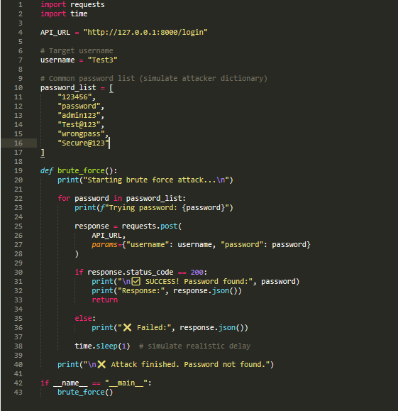
1. Brute Force attack
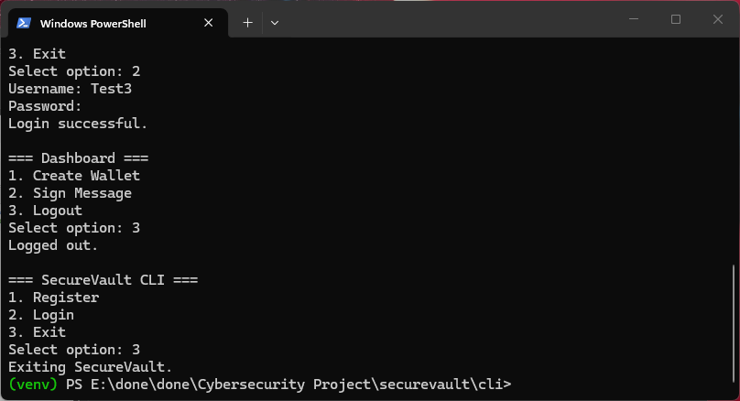
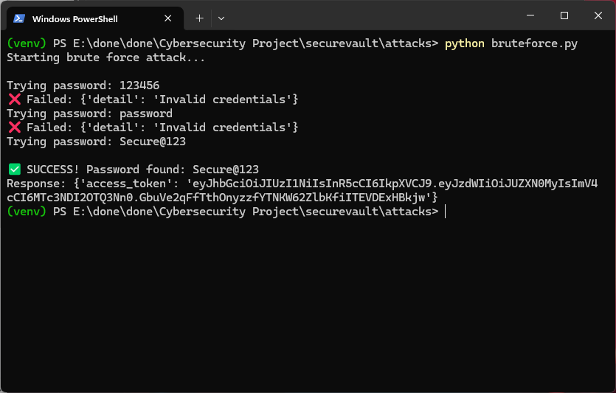
Brute force protection
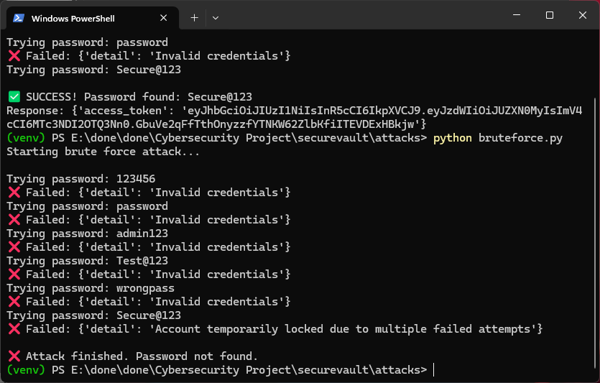

2.2 Clipboard Hijacking Attack

Objective
This attack aimed to masquerade as malicious software, which tracks clipboard activity and substitutes copied cryptocurrency wallet addresses with an address that is controlled by the attacker during transactions.

Implementation
In order to spy the system clipboard, a Python script called clipboard attack.py was created to follow up the system clipboard with a clipboard access library. The script verifies new copies and finds patterns that are similar to a cryptocurrency wallet address. On receiving such an address and satisfying the specified length requirement, the script makes a copy of the original value and substitutes it with an attacker-address. It also shows messages that show the replacement activity. When the script is halted, the initial clipboard content is reinstated so that the simulation behaviour can be controlled.

Security Risk
This attack poses a severe security threat since users can paste a compromised wallet address without knowing it when making transactions. Consequently, money can be sent to the address of the attacker rather than the recipient with no detection.

Mitigation Awareness
To avoid such attacks, users are urged to always check the wallet addresses prior to confirming a transaction. Address verification and warning functionality should be embedded in wallet applications to identify wrong or suspicious addresses to help users not accidentally transfer to unauthorised or malicious destinations.
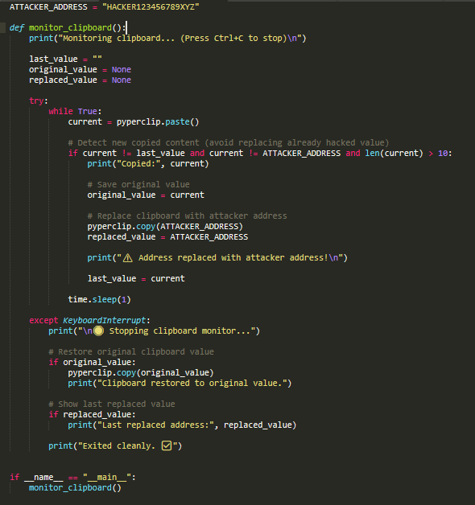
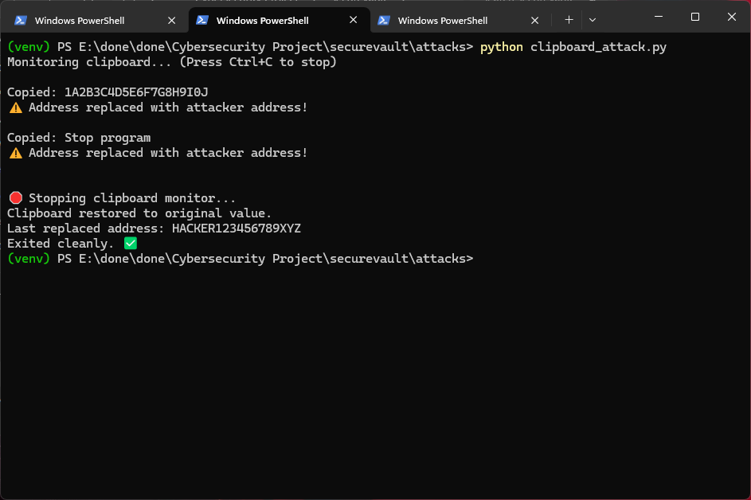

2.3 Phishing Simulation

Objective
This simulation was aimed at illustrating how attackers can exploit the use of a false login interface to deceive users into inserting their credentials, which allows them unauthorised access and possible loss of sensitive account details.

Implementation
A Python script was designed to imitate a simulated SecureVault CLI interface to login that resembles the original system. The script also asks the user to input a username and a password, simulating an actual login. On failure, it will show the error message about the server unavailability after a delay to avert suspicion. In the meantime, the credentials typed in are captured and saved in a local file with time stamp. The script then displays the stolen data, which shows the process of attackers stealing sensitive user data.

Outcome
The simulation has been able to intercept the user credentials typed in the simulated interface, showing that phishing attacks can be easily used to mislead users, resulting in unauthorised access in case of lack of proper awareness.

Mitigation
Users should be trained on how to recognise suspicious interfaces and to ensure that the application is genuine before entering credentials to minimise the chance of being victims of phishing attacks. Multi-factor authentication (secure authentication methods) should be promoted. Users should not input sensitive information on a system that is unfamiliar to them or a system they do not trust. The threats of successful phishing attacks can be greatly minimised by regular awareness training and security practices.
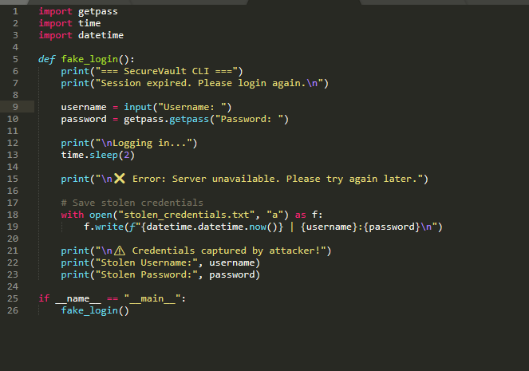
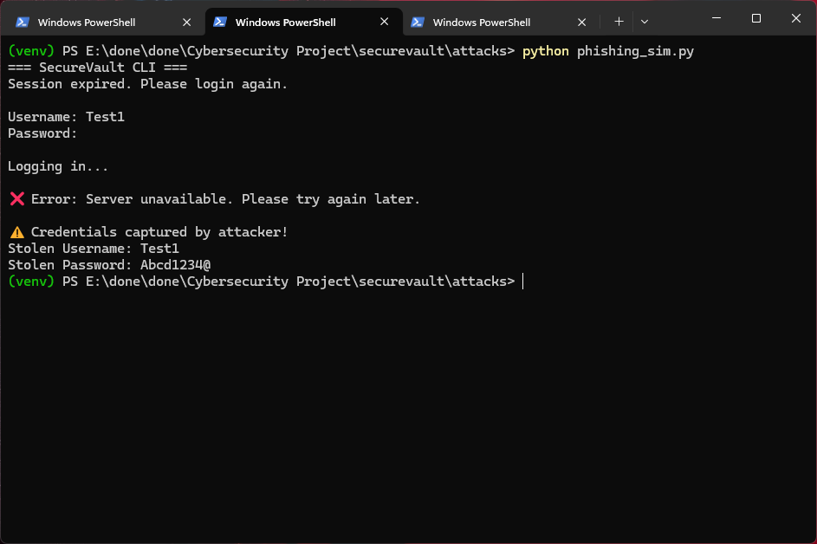

2.4 SQL Injection Test

Objective
The purpose of this test was to test the vulnerability of the backend system to SQL injection attacks by entering malicious inputs and assessing the security of the processing done by the system.

Implementation
To simulate SQL injection attempts, a Python script was written that would send various malicious payloads to the login API. These were payloads set in the username field, and the password was generic. The script made several requests with typical SQL injection patterns to determine whether it is possible to access without permission.

Result
The SQL injection attacks failed, with the system not accepting any ill-intentioned input and no unauthorised access being provided in the testing process.

Reason
This attack was not successful since the backend is interacting with the database using SQLAlchemy ORM rather than the SQL query in raw mode. The methodology automatically cleanses user inputs and blocks the execution of malicious SQL commands, thus safeguarding the system against attacks based on injection, and ensures secure processing of user-supplied data.
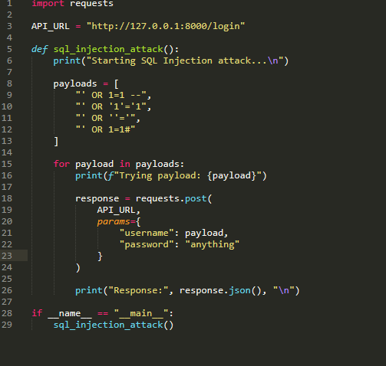
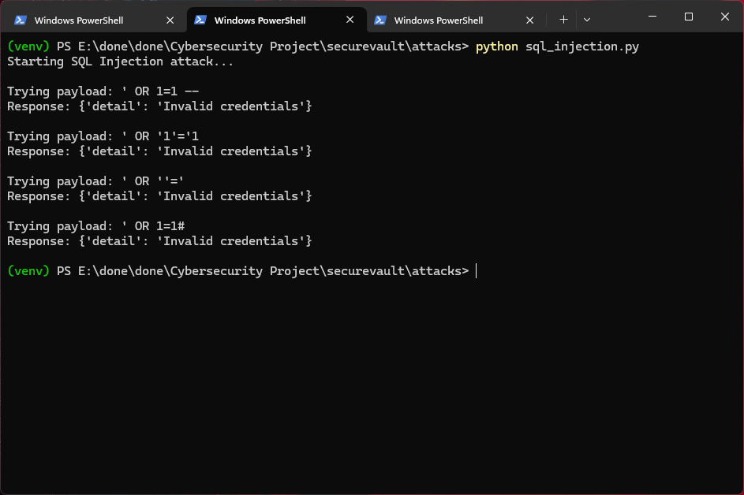

3. Payment Integration (Razorpay)

Objective
This module aimed to introduce business functionality to the application by introducing a subscription model that enables users to pay to upgrade their accounts and enjoy premium features.

Implementation
The Razorpay payment gateway was connected to the backend with its API keys that are securely stored in the environment variables. On the selection of the premium option in the CLI, a payment request is submitted to the backend, which prepares an order with the help of Razorpay. A custom HTML interface is then used to open up a payment page in the browser. This interface shows the SecureVault premium plan, pricing information and payment button. In test mode, users key in their card details in the Razorpay checkout form. At the back end, once the transaction is completed, the backend authenticates the transaction and changes the subscription status of the user in the database, thereby ensuring that secure payment processing has been successfully integrated.

Flow
The process of payment starts once the user checks the premium upgrade button in the CLI, which makes a request to the backend. The backend makes a Razorpay order and provides a payment interface. The customer fills in the Razorpay checkout system.

Outcome
The integration is effective in enabling users to convert their free accounts to premium in a safe payment system. After verifying the payment, a subscription status is updated and saved in the database. Premium users are provided with more features in the application. This application is a practical business attribute with safe management of economic transactions and users' information.
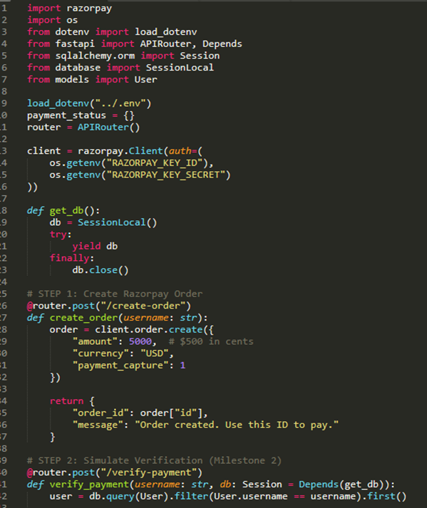
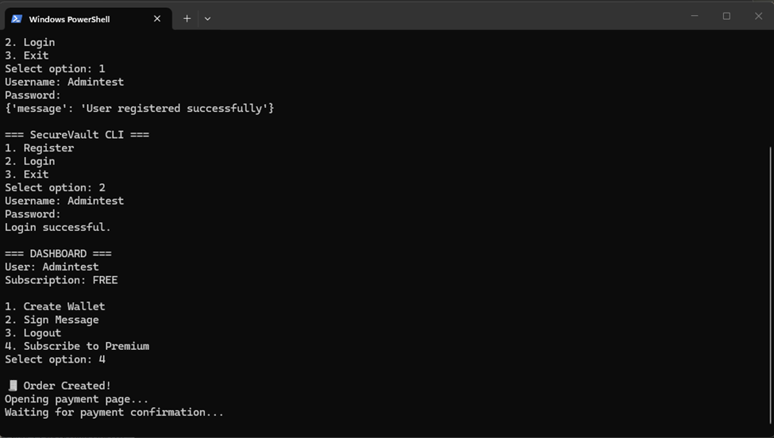
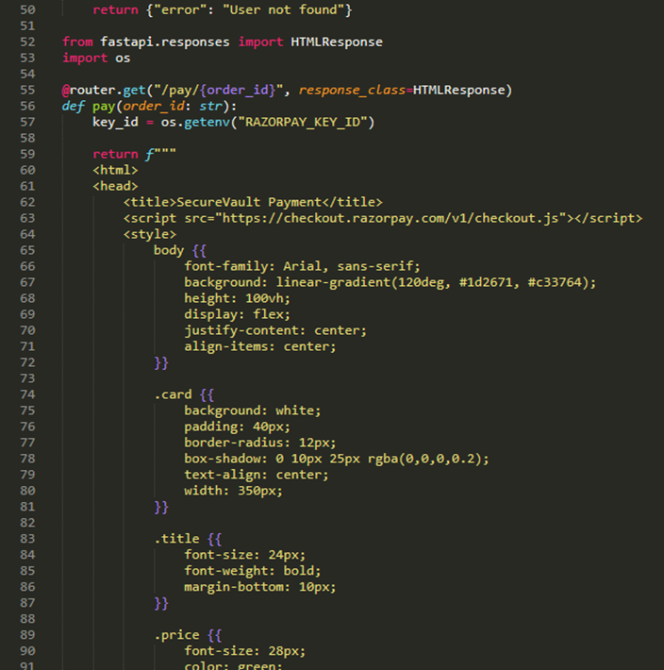
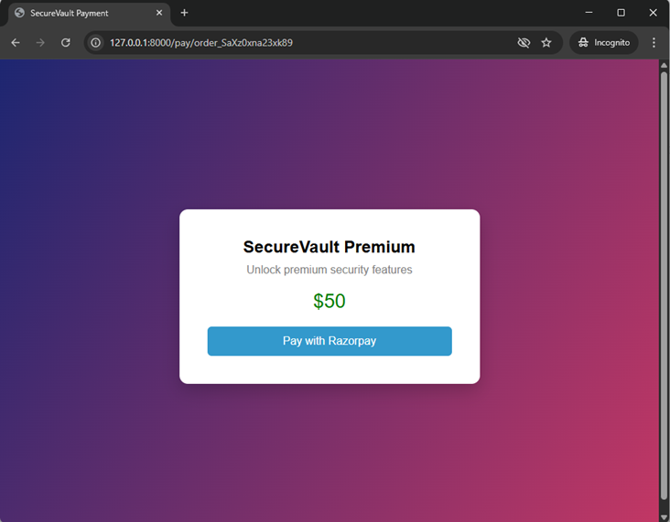
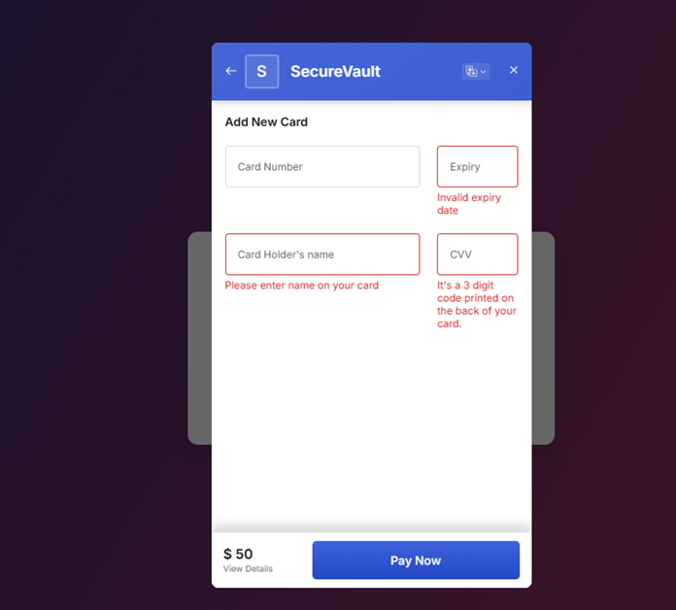
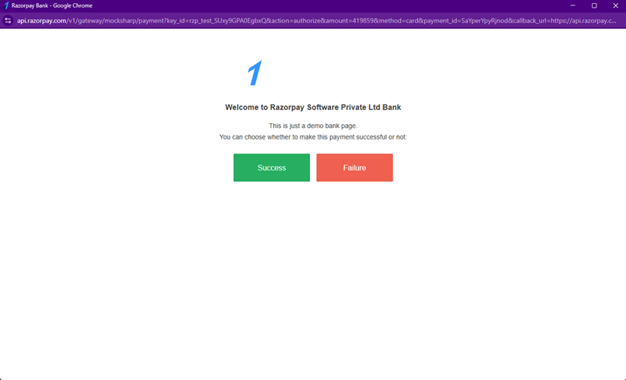
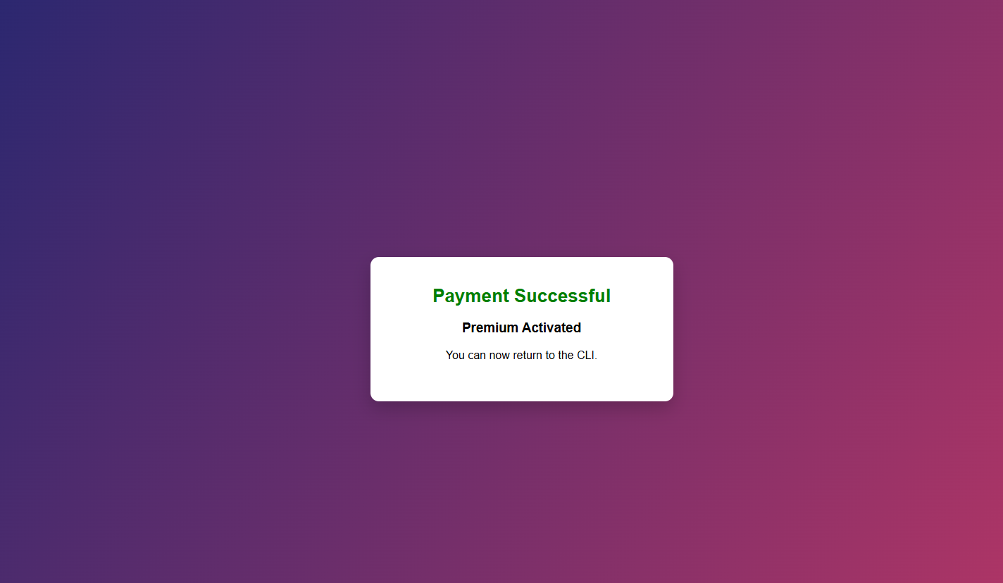
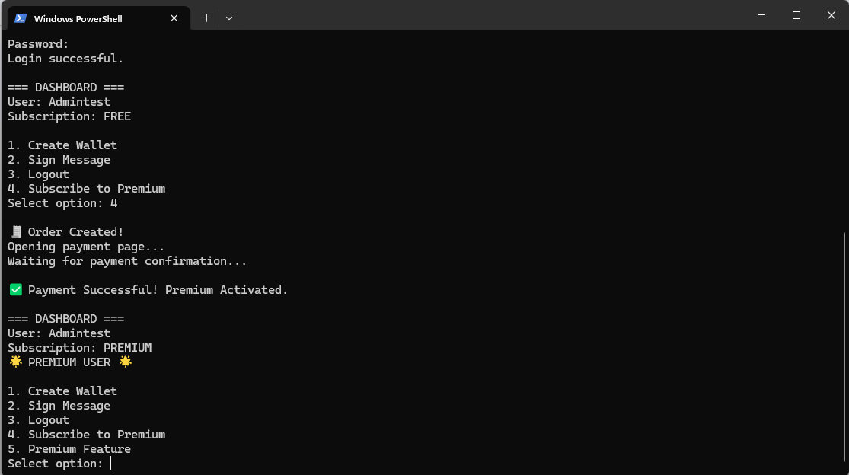

4. Premium Feature System

Features
The upgrade to the premium feature system offers more features to those users who choose to upgrade their subscription. Premium users have access to features which are not allowed to free users. The CLI interface shows a clear message on premium status, which enables users to distinguish their upgraded level of access.

Access Control
The system applies access control, whereby some features are restricted according to whether a user is subscribed or not, making sure that only premium users can access exclusive features without jeopardizing.

5. Admin Panel

Objective
This module aims at offering administrative control of the system and allowing monitoring of user activities, roles and subscription information effectively.

Features Implemented
The admin panel has some key features that enable the effective administration of the system. Administrators will be able to see a full overview of registered users and their roles and subscription status. The system would check the user as a normal user or an admin and whether he/she has a free plan or a premium plan. It also allows promoting users to the position of an administrator and controls their access levels. Also, a dashboard interface is provided to provide a summary of the activity and distribution of users in the system.

Dashboard Information
The dashboard shows important system statistics, which assist administrators in knowing the state of the application at the given time. It provides the total number of users registered in the system and number of users who have opted to upgrade to premium subscriptions, and the number of users with access to the system as administrators. This is a summary of information that gives a clear and quick overview of the usage of the system and the distribution of users.

Importance
The administrator panel is also important in ensuring the security of the system and its organisation. It allows administrators to keep track of user activity and control access. It supports role-based access control, and hence only authorised users can perform sensitive operations. It also makes system management easier as it offers centralised control over users and subscriptions and assists in ensuring a secure and well-managed application environment.
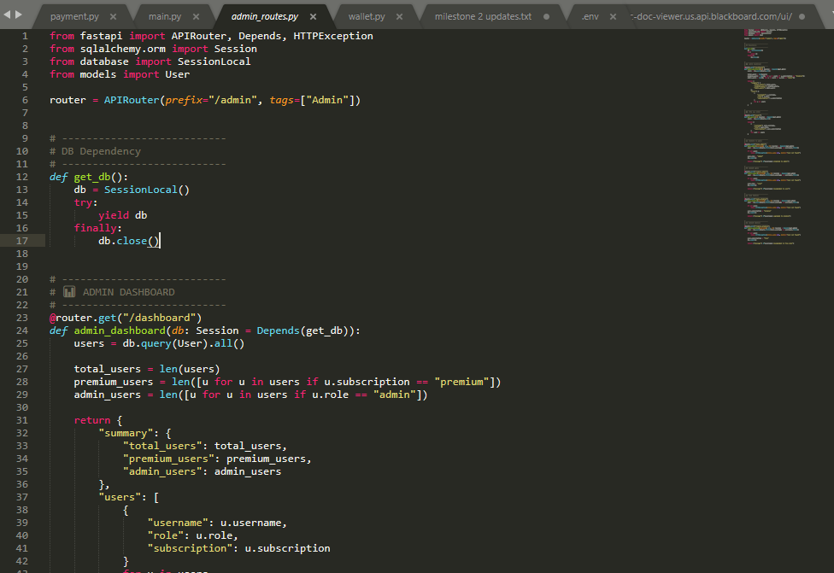
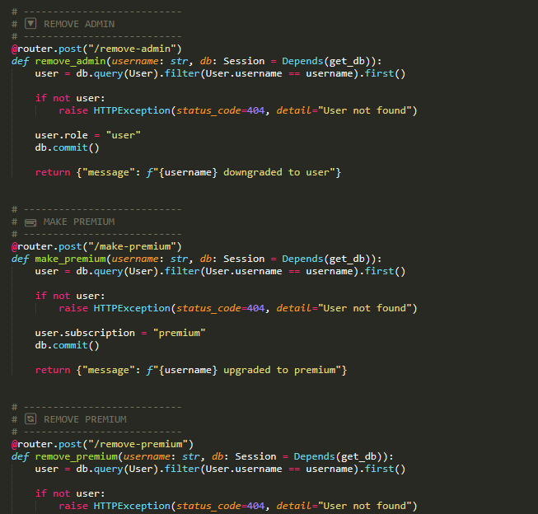
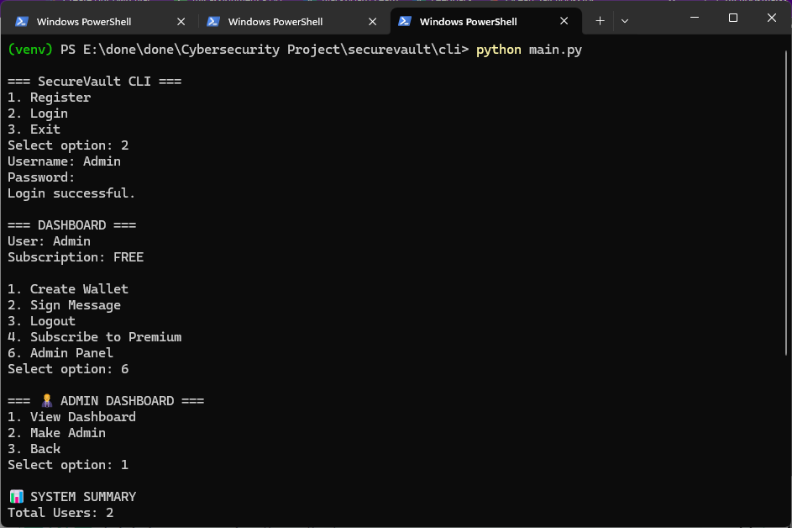
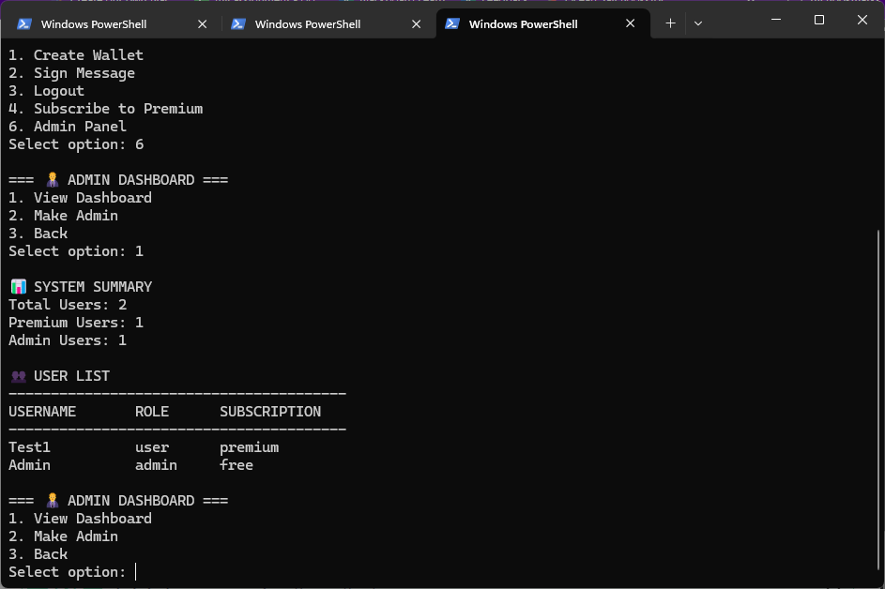

6. Security Enhancements
The system packs a solid set of security features to keep user data safe and the app running smoothly. For starters, passwords are hashed with bcrypt, making them hard to crack, even if someone gets their hands on the database. The setup uses JWTs to handle sessions, so only authorised users get access. Users need to pick strong passwords—no simple guesses allowed, thanks to strict validation rules. Plus, the system keeps an eye on repeated failed logins to catch and slow down brute force attacks.
Sensitive aspects like private cryptographic keys stay locked away, so nothing valuable leaks out. The app stops brute force attacks by capping the number of login tries. SQL injection isn’t a problem either, since it uses safe ways to talk to the database. Finally, important secrets like API keys and credentials stay out of the main code—they’re handled with environment-based configs, keeping the good stuff well out of sight.

7. Threat Modelling
It used the STRIDE threat modelling method to examine what could jeopardise the security of the main parts of the system, especially authentication, wallet storage, and API endpoints, to help us think about what types of threats might compromise both the user's data as well as the integrity of the system. In order to avoid unauthorised users trying to impersonate a legitimate user (spoofing), we put mechanisms in place to protect against unauthorised access of this nature. With regard to tampering, protection has been put in place to prevent someone who has access to the system from changing any stored data in a malicious way and/or altering any data while in transit. We will also ensure that there is proper logging of user activity, and therefore, the appropriate level of accountability for users will be created by reviewing repudiation analysis. Sensitive data (like private keys and passwords) that must remain confidential will be secured to avoid any possible disclosure (information disclosure) of user information. A denial of service attack will cause users of the system to be unable to use the system, either due to too many users trying to access it at the same time, for any length of time, or being the target of some type of attack. Elevation of privilege was addressed through the implementation of strict role-based access control, so users will not have the ability to perform unauthorised administrative functions within the system.

8. Conclusion
This milestone reflects how real-world attacks are modelled using Real-World Attack Models and the various Security Defences available and the Mitigation Strategies employed within the SecureVault application. Additionally, the integration of a Commercial Payment System allows Users to pay for upgrades to Premium Features securely. The addition of a Role-Based Admin Panel will provide Systems Administrators with enhanced system control and Monitoring capabilities over the application. Overall, the SecureVault project has grown from a Simple Secure Wallet to an advanced Security Aware Application that has been extensively tested against possible attack types, which can support Real-World Use Cases as well as Business Use Cases.

